Planning Proposal

Schedule 1 Amendment to permit a General Industry (erosion mat manufacturing) at 464 Broadwater Road, DUNGARUBBA (Lot 3 DP 593867)

November, 2019



Contents

Part 1 - Objectives or Intended Outcomes 3

Site description and setting 3

Planning Proposal 4

Part 2 - Explanation of Provisions 6

Part 3 - Justification 6

Section A - Need for the Planning Proposal 6

Section B – Relationship to strategic planning framework 7

Section C – Environmental, social and economic impact 8

Section D – State and Commonwealth interests 12

Part 4 - Mapping 13

Part 5 - Community Consultation 14

Part 6 - Project Timeline 14

Conclusion 14

APPENDIX 1 Compliance with applicable State Environmental Planning Policies 15

APPENDIX 2 – Compliance with Section 9.1 Ministerial Directions 16

# Part 1 - Objectives or Intended Outcomes

The objective of this planning proposal is to amend Schedule 1 of the Lismore Local Environmental Plan 2012 to allow an additional permitted use, being a General Industry (manufacturing of erosion mats) at 464 Broadwater Road, Dungarubba (Lot 3 DP 593867).

## Site description and setting

Lot 3 DP 593867 (464 Broadwater Road, Dungarubba) is located approximately 30 kilometres by road south of Lismore’s urban area. The land is within Zone RU1 (Primary Production) and has an area of 42.21 hectares with frontage to Broadwater Road. It is currently used for sugar cane and cattle farming. As shown in Figure 2 below, the surrounding land is all zoned RU1. Adjoining land uses are predominantly sugar cane cropping and cattle grazing with rural dwellings interspersed throughout. A rural lifestyle lot of 2 hectares adjoins the land directly to the south. Further west at 354 Broadwater Road (Lot 2 DP 8877) is an approved industrial activity for the manufacturing of concrete posts that was previously enabled via a similar Planning Proposal to amend Schedule 1 of the Lismore LEP and approved under DA15/357.

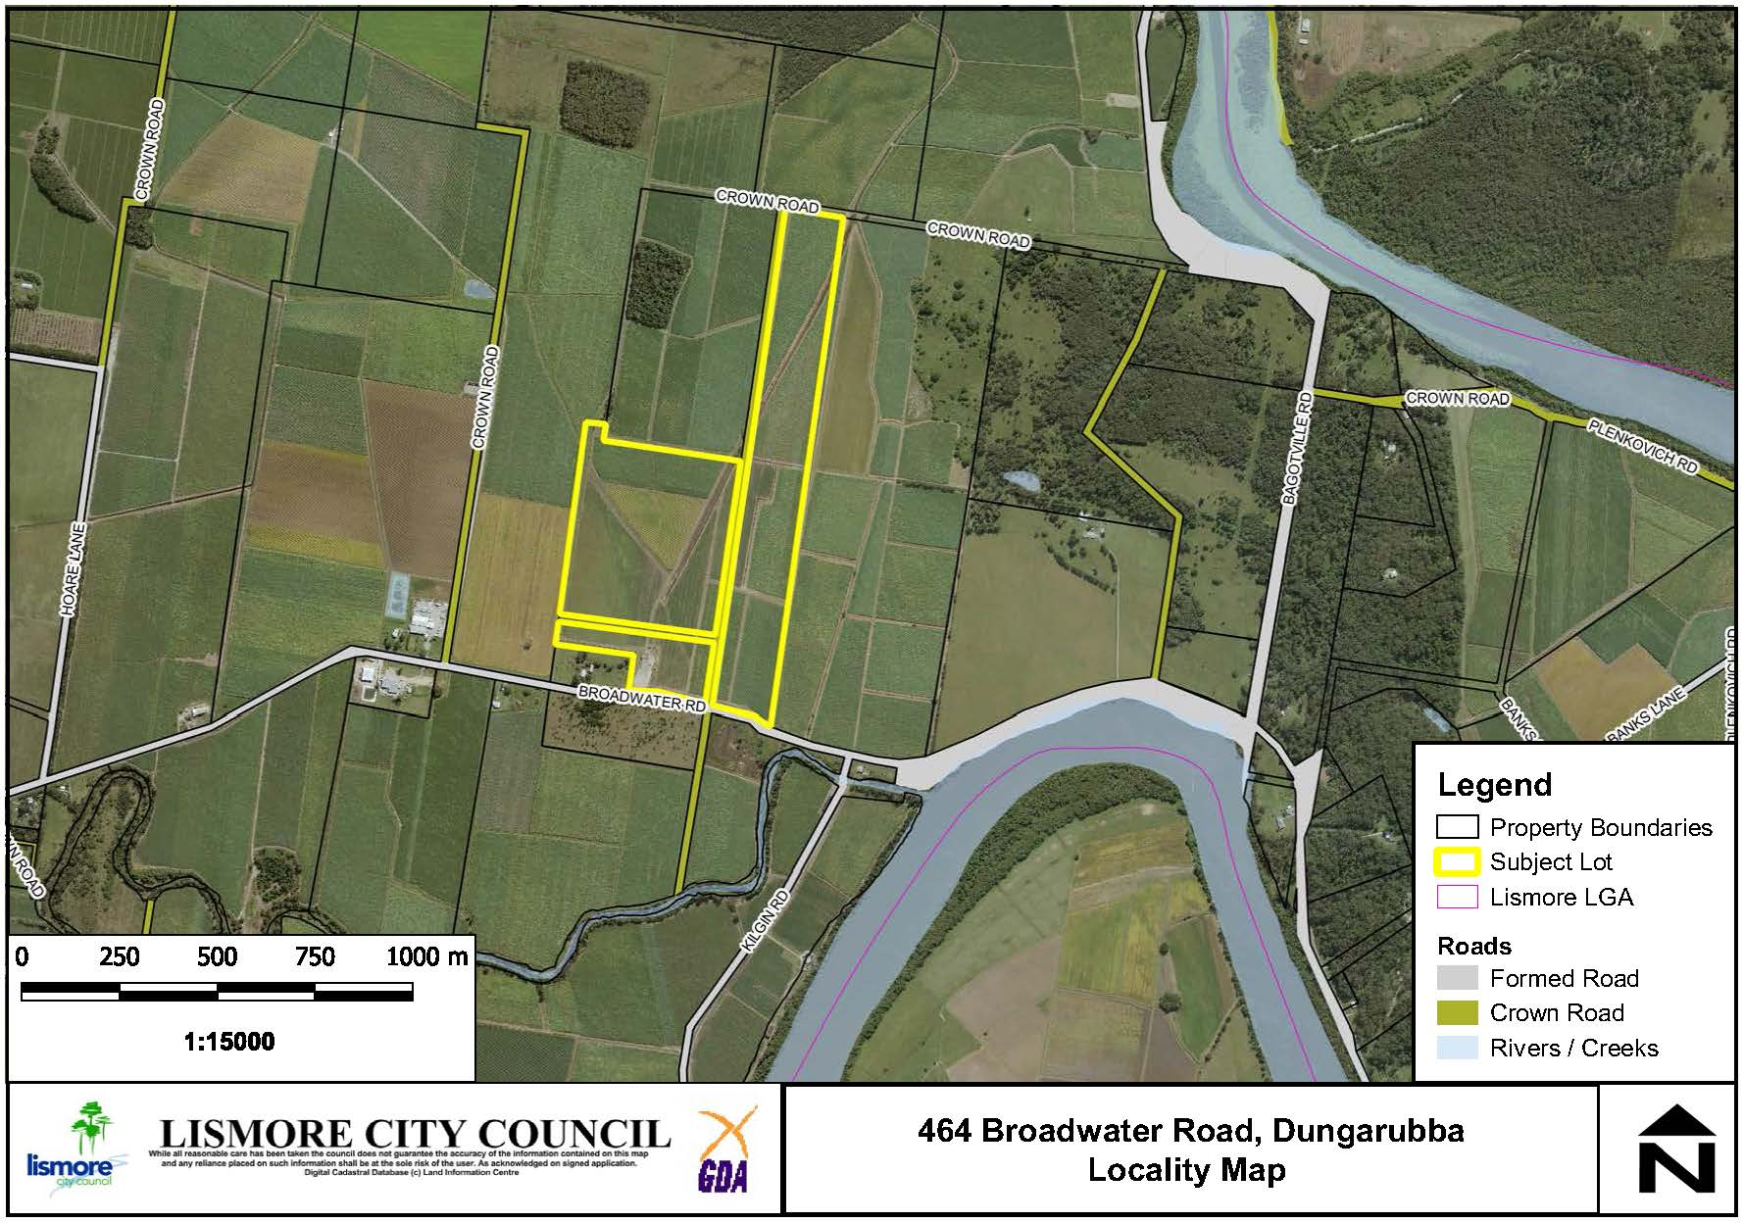

**Figure 1: Locality of the subject site.**

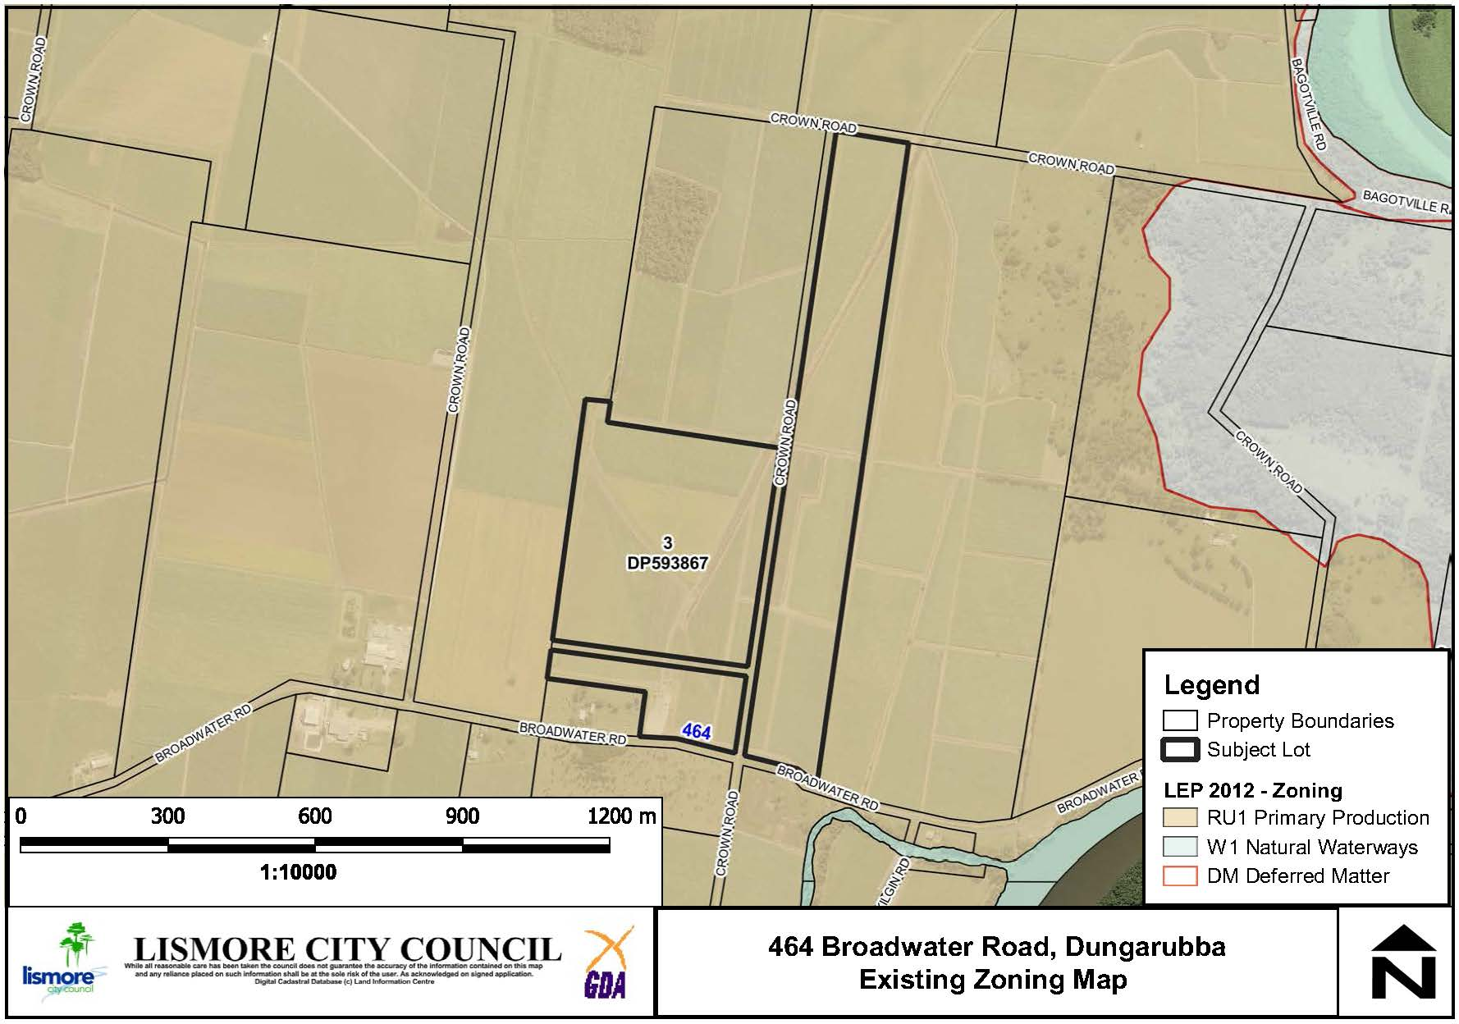

**Figure 2: Current Lismore LEP zoning for 464 Broadwater Road and surrounding properties.**

The land has been cleared of vegetation and therefore contains no koala habitat or other high conservation value areas. The site is not mapped as containing bushfire prone vegetation.

## Planning Proposal

The approval of the Planning Proposal to permit a General Industry (manufacturing of erosion mats) for the subject land in Schedule 1 would allow Council to assess and determine a development application to use part of the site for the purpose of manufacturing concrete erosion mats.

The production process has specific and unique requirements in that a flat linear surface 24 metres wide and greater than 500 metres in length is required, as shown in Figure 3. No land zoned for industrial use within the Lismore LGA meets the operational and logistic requirements of the proposed business. Therefore the applicant is seeking an additional permitted use on land zoned RU1 at 464 Broadwater Road, Dungarubba (Lot 3 DP 593867).

The area required for the proposed General Industry is approximately 3.3 hectares as shown Figure 4 and includes an area of closed Crown road.

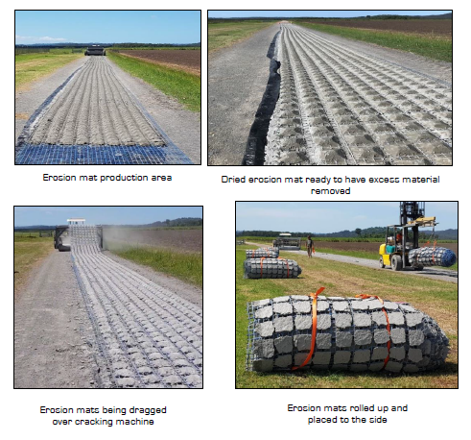

**Figure 3: Images demonstrating site requirements for erosion mat production.**

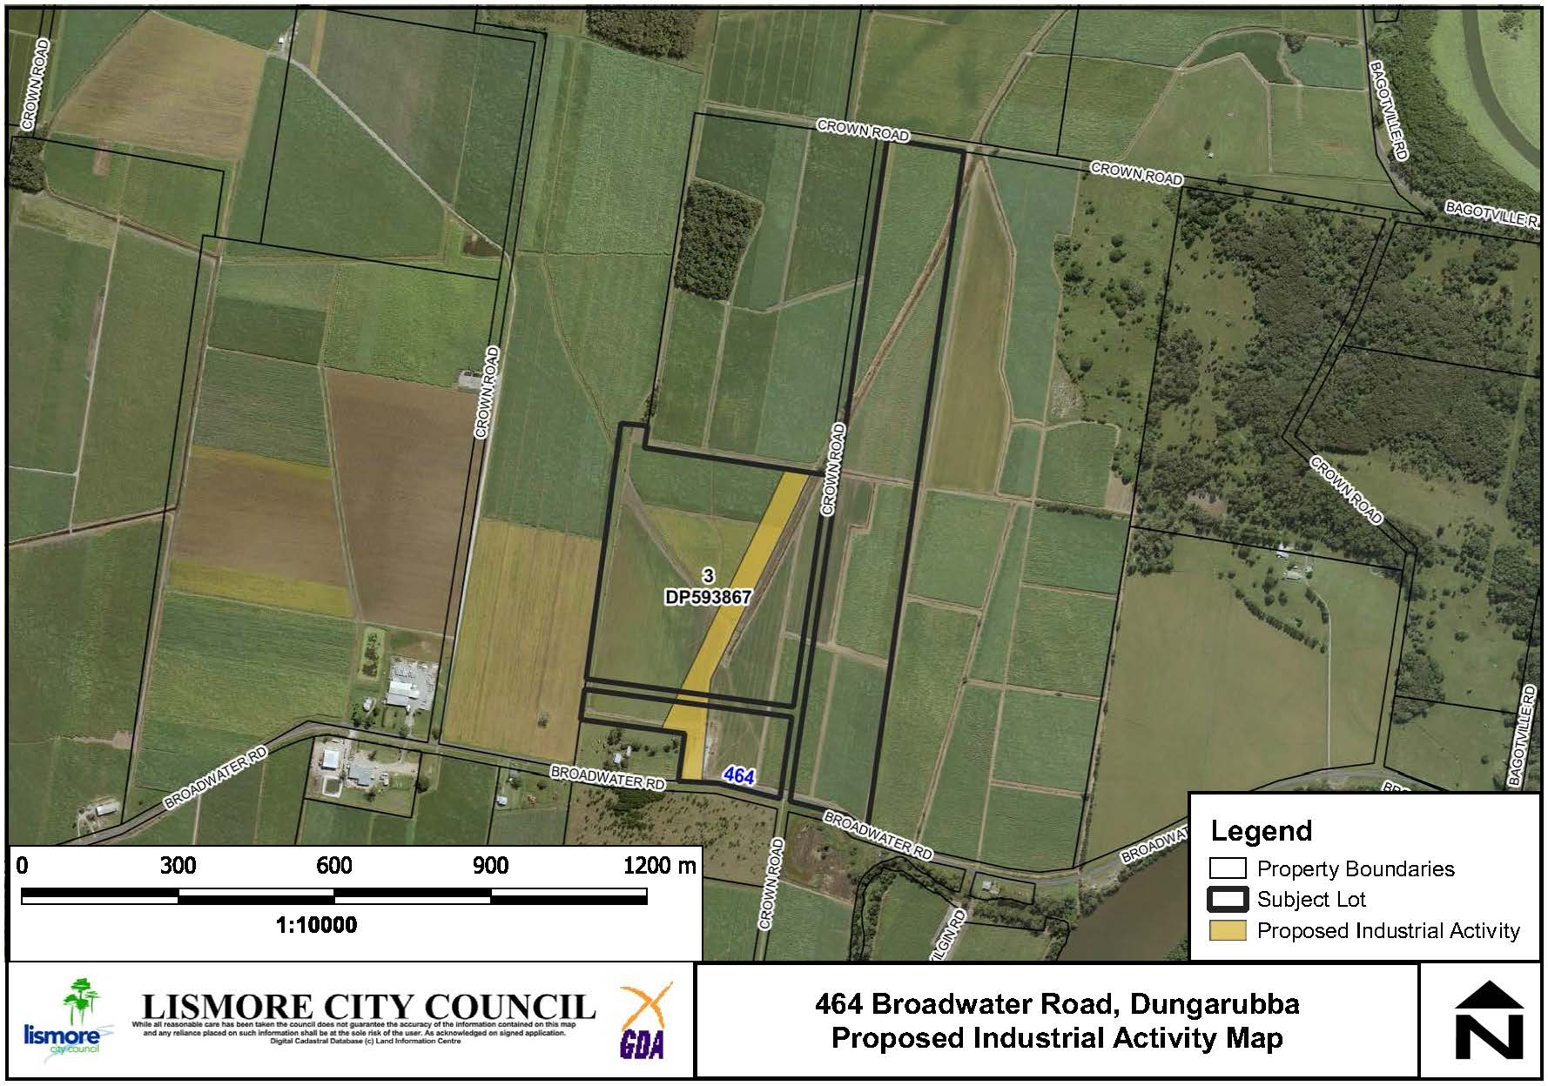

**Figure 4: Area of the proposed industrial activity at 464 Broadwater Road.**

# Part 2 - Explanation of Provisions

The objective of the proposal will be achieved by amending Schedule 1 of the Lismore Local Environmental Plan (LEP) 2012 by the inclusion of an additional permitted use to permit an industry, being the manufacturing of erosion mats. The proposed insertion into Schedule 1 is:

**7 Use of certain land at 464 Broadwater Road, Dungarubba**

1. This clause applies to the part of the land at 464 Broadwater Road, Dungarubba, being approximately 3.3 hectares at Lot 3 DP 593867 identified as “Item 7” on the Additional Permitted Use Map.
2. Development for the purpose of a General Industry (limited to the manufacturing of concrete erosion mats) is permitted with development consent on the land to which this clause applies.

An amendment to the Additional Permitted Use Map to identify part of Lot 3 DP 593867 in accordance with Figure 10 in Section 4 of this report is also required.

# Part 3 - Justification

## Section A - Need for the Planning Proposal

#### **Q1. Is the planning proposal a result of any strategic study or report?**

No, the planning proposal is not the result of any strategic study or report. The proposed land use is prohibited in zone RU1 but is considered to be consistent with the following zone objectives;

* *To encourage diversity in primary industry enterprises and systems appropriate for the area.*
* *To enable a range of other uses to occur on rural land providing such uses do not conflict with existing or potential agriculture and do not detract from the scenic amenity and character of the rural environment.*

There is currently no industrial zoned land in the Lismore LGA which provides the size and lineal production length of 500 metres to meet the production requirements of the operation, nor is there any suitable land identified in Council’s Growth management Strategy.

The applicant undertook a pre-lodgement meeting with Lismore City Council and was advised that due to the unique characteristics of the site requirements for the proposal, a Planning Proposal to amend the LEP for a site specific use would be the most appropriate way to enable the development.

#### **Q2. Is the planning proposal the best means of achieving the objectives or intended outcomes, or is there a better way?**

Yes, the Planning Proposal is required to amend Schedule 1 Additional Permitted Uses of the Lismore LEP 2012. This is considered to be the most practical method of achieving the aims of permitting an industry (manufacture of erosion mats) at 464 Broadwater Road, Dungarubba (Lot 3 DP 593867).

This outcome is preferred to a rezoning of the site because RU1 Primary Production remains an appropriate zone on the land. Under the Lismore LEP 2012 a ‘general industry’ is permitted with consent in zone IN1 General Industrial; however, rezoning the site is not considered appropriate given the rural location and surrounding land uses are predominantly agricultural and rural residential.

## Section B – Relationship to strategic planning framework

#### **Q3. Is the planning proposal consistent with the objectives and actions of the applicable regional or sub-regional strategy?**

The North Coast Regional Plan (NCRP) is the current overarching State Government framework to sustainably manage growth for the Far North Coast and allocate further development of land for residential and employment purposes in appropriate locations.

While the subject site is not identified as an investigation area for employment land, this Planning Proposal reinforces the following directions:

**Direction 6: Develop Successful Centres of Employment –** the Planning Proposal will permit a development application to be lodged and assessed for new industrial use on the site and facilitate the ongoing employment of approximately six (6) staff.

**Direction 11: Protect and Enhance Productive Agricultural** **Lands** – The site is mapped as being regionally significant farmland. The Planning Proposal seeks to utilise a redundant internal driveway together with the existing cane pad at the front of the property for access. The balance of the property will be retained for farming activities and the applicant has indicated an intention to plant macadamia trees on the remaining land. The Planning Proposal will not remove any land from the RU1 zone in the Lismore LEP 2012. The intended use for industry is not expected to diminish the agricultural productivity of the land and continued use for agriculture in the future.

#### **Q4. Is the planning proposal consistent with a council’s local strategy or other local strategic plan?**

Yes, the Planning Proposal is consistent with the **Imagine Lismore (Community Strategic Plan) 2017-2027.** The Imagine Lismore Community Strategic Plan (CSP) was developed and adopted by Council in accordance with the *Local Government Act 1993*. The plan identifies the main priorities and aspirations for the future of the LGA for a period of 10 years. The planning proposal is consistent with the following objectives in the CSP;

* *Our land use planning caters for all sectors of the community*
* *Ensure a diverse range of land use development opportunities are available, and*
* *Monitor the Local Environmental Plan and amend as required in response to community and development industry need*

This Planning Proposal responds to the development industry’s need to consider a land use activity that is currently prohibited on land zoned RU1 by the LEP 2012, but is considered to be consistent with the objectives of the zone.

**Lismore Growth Management Strategy 2015-2035**

The principal aim of the Growth Management Strategy (GMS) is to ensure sufficient land is available for residential, commercial and industrial development in suitable locations in the Lismore LGA. The GMS identifies that there is sufficient industrial zoned land to meet the projected needs of industrial uses within the time horizon. However, the unique requirements of the proposal mean that there is not any suitable land zoned IN1 and none identified within the GMS. Therefore the Planning Proposal to allow an additional permitted use on the subject site is unlikely to have any impact on the availability of industrial zoned land in the longer term.

#### **Q5. Is the planning proposal consistent with applicable State Environmental Planning Policies?**

The Planning Proposal is consistent with the requirements of the applicable State Environmental Planning Policies (SEPPs). An assessment against relevant SEPPs is provided at **Appendix 1**.

#### **Q6. Is the planning proposal consistent with applicable Ministerial Directions (s.9.1 directions)?**

The proposal is consistent with applicable Section 9.1 Directions or any inconsistency can be justified. An assessment against the Ministerial Directions is provided at **Appendix 2**.

## Section C – Environmental, social and economic impact

#### **Q7. Is there any likelihood that critical habitat or threatened species, populations or ecological communities, or their habitats, will be adversely affected as a result of the proposal?**

The subject site has been cleared as a result of historical activities and is not identified in Council’s GIS mapping as containing any significant areas of vegetation for koala habitat and the land is not mapped as containing areas of high biodiversity value on the Biodiversity Values Map tool.

#### **Q8. Are there any other likely environmental effects as a result of the planning proposal and how are they proposed to be managed?**

**Contaminated Land**

The site is identified within Council’s mapping as being potentially contaminated land as a result of the current sugar cane use. The nature of the proposed land use will not trigger the requirement for any further technical reporting by way of a preliminary contaminated land assessment as the activity will be undertaken on imported hard stand areas and there will be no disturbance of the soil environment.

**Flooding**

The land is prone to flooding. The relevant provisions of the LEP can be addressed with any subsequent development application.

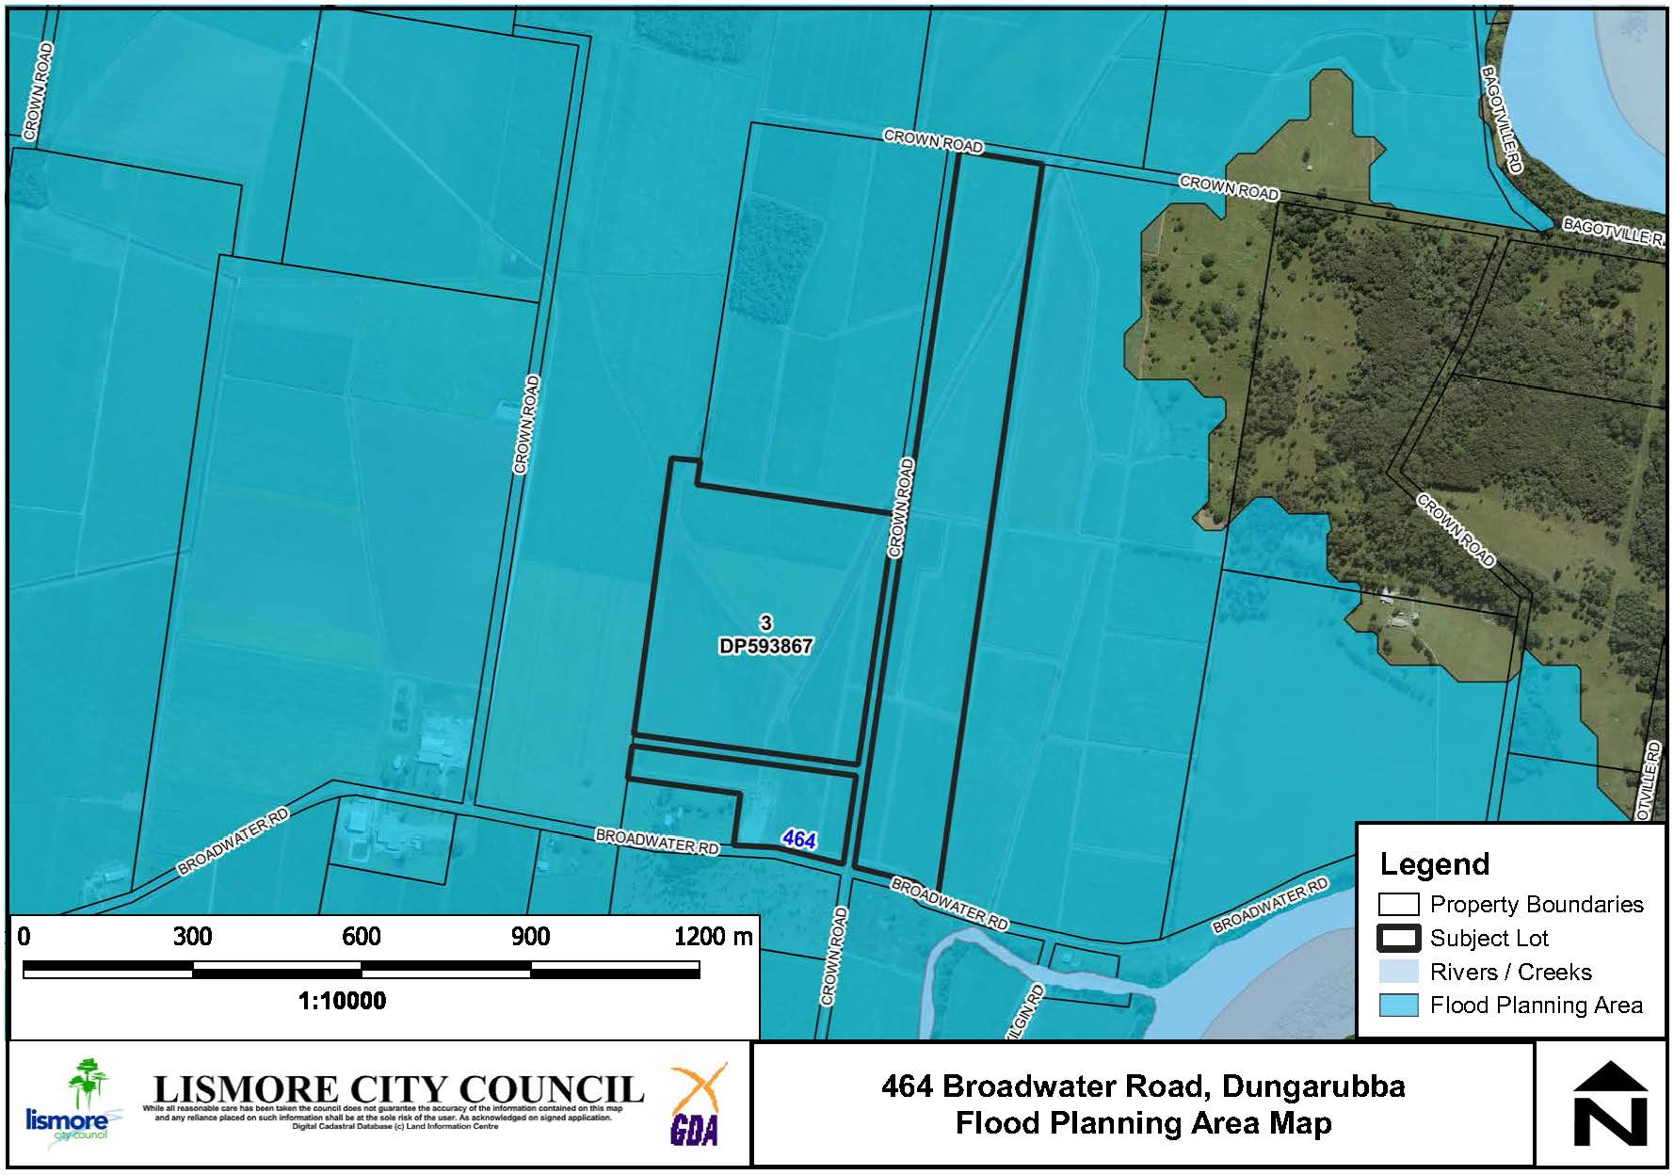

**Figure 5: Flood Planning Area**

**Buffers to Watercourses**

The site is not within the drinking water catchment. LCC mapping indicates an Order 1 stream running in NW – SE on the western side of the property and an Order 8 stream running adjacent to the driveway proposed for the manufacturing area of the erosion mats. There is an existing drainage channel under the road proposed to be used for the construction of erosion mats that will not be impacted by the proposed land use. Therefore the existing flow of water will not be impacted. The management of washdown waters and other waste can be addressed through any subsequent development application.

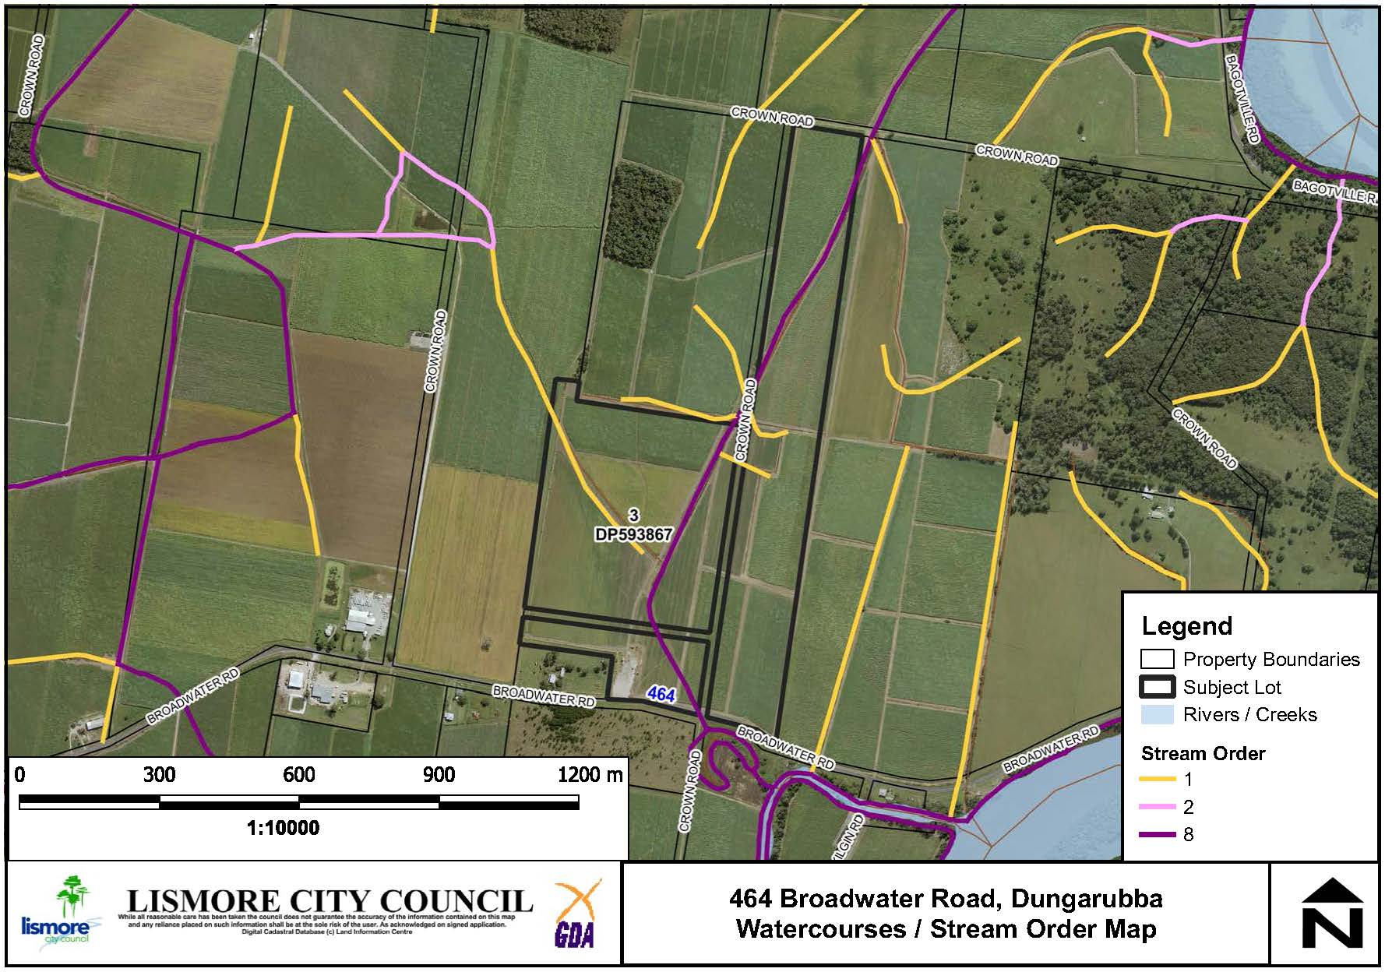

**Figure 6: Existing watercourses**

**Acid Sulphate Soils**

The area is mapped as containing Class 3 Acid Sulfate Soils. No significant earthworks are proposed to be undertaken to facilitate operations and therefore no technical reporting on this matter is required. The relevant provision of the LEP will be addressed with any subsequent development application.

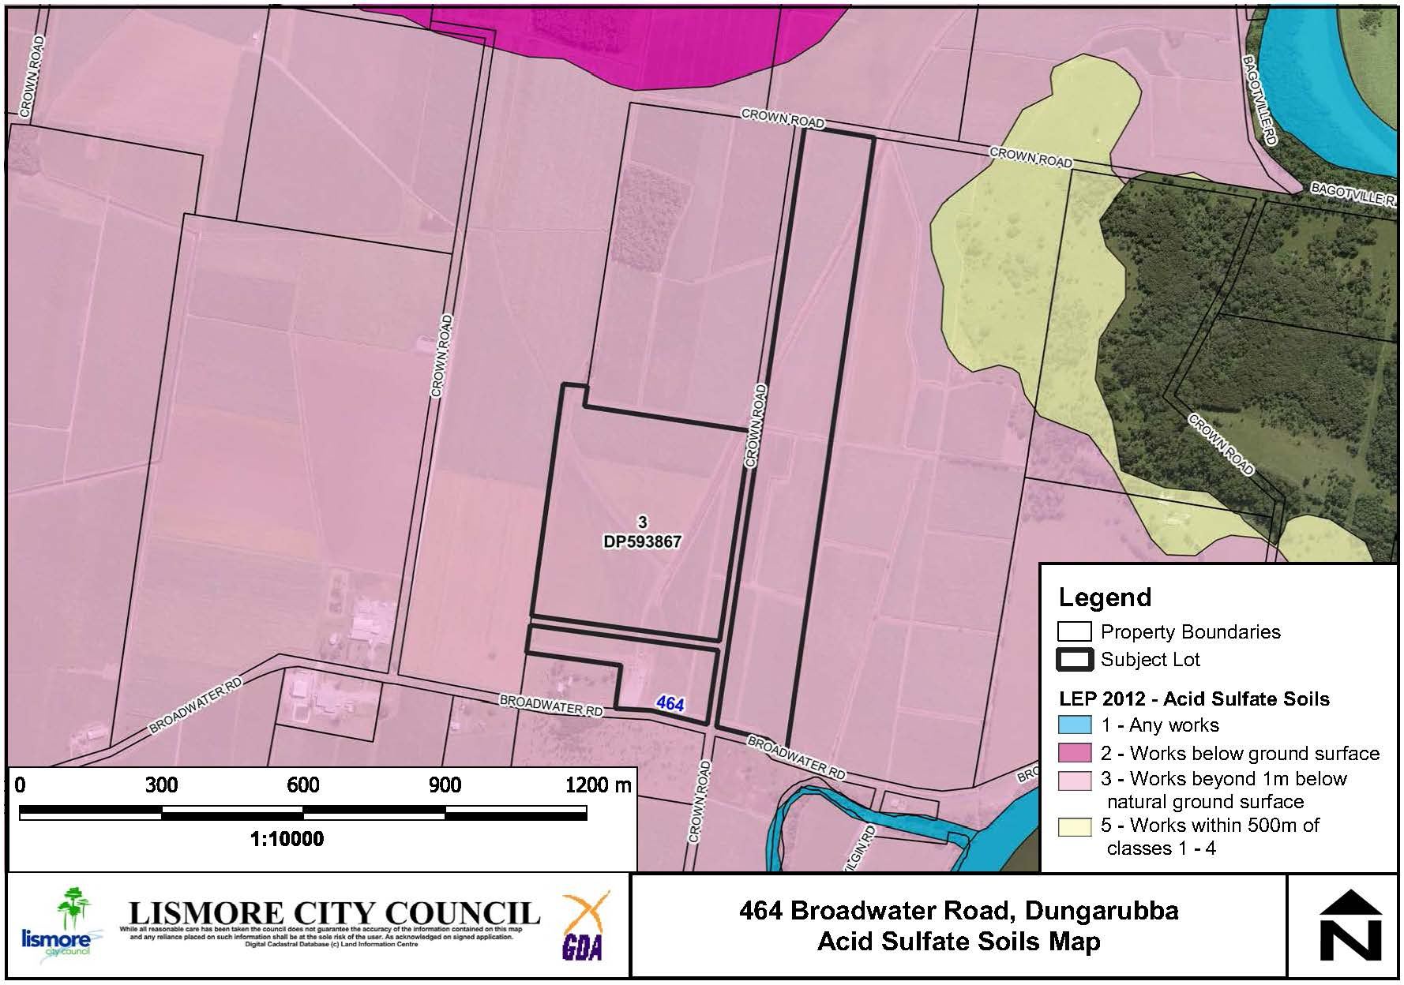

**Figure 7: Acid Sulfate Soils**

**Land Use Conflict**

A Land Use Conflict Risk Assessment (LUCRA) has been undertaken by consultants Newton, Denny Chapelle. A map showing surrounding land uses (See Figure 8 below) was provided and the LUCRA evaluated risks from noise and dust. The nearest dwelling is located approximately 160m from the proposed industrial activity. Council’s DCP recommends a buffer of 40m from general industries to residential lots. The buffers prescribed by Council’s DCP have been assessed and shown to meet requirements. Furthermore a range of management mitigation measures have been identified including hours of operation which can be addressed with any subsequent development application.

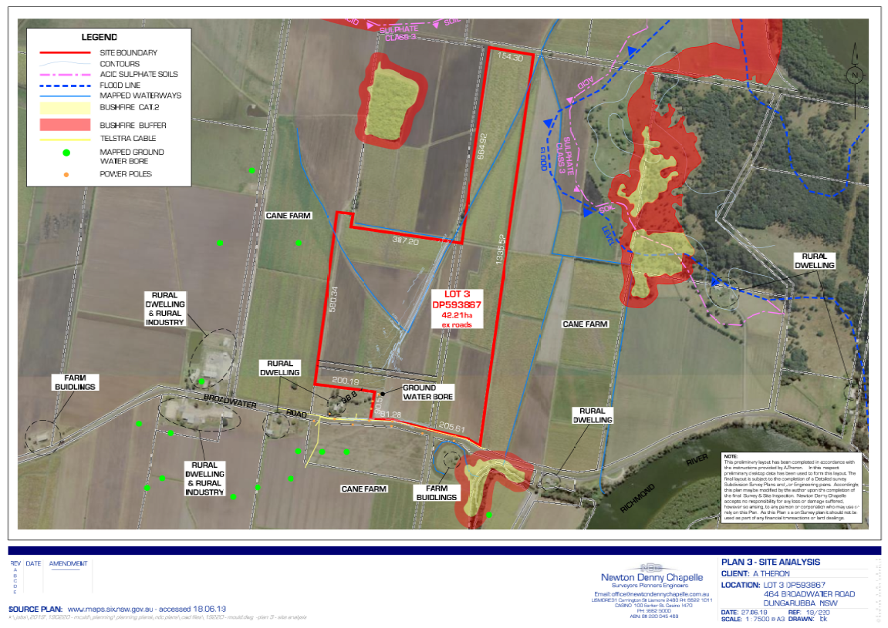

**Figure 8: Surrounding land uses**

**Regionally Significant Farmland**

The site is mapped as regionally significant farmland**.** The proposal is for an area of 3.3 hectares to be utilised for a General Industry, with the remaining 39 hectares to continue to be used for productive agriculture. The applicant has indicated the majority of the land will be planted with macadamias. The Planning Proposal will not remove any land from the RU1 zone in the Lismore LEP 2012 and it is anticipated that the impacts of the proposed industrial use are considered negligible on the agricultural use of the land.

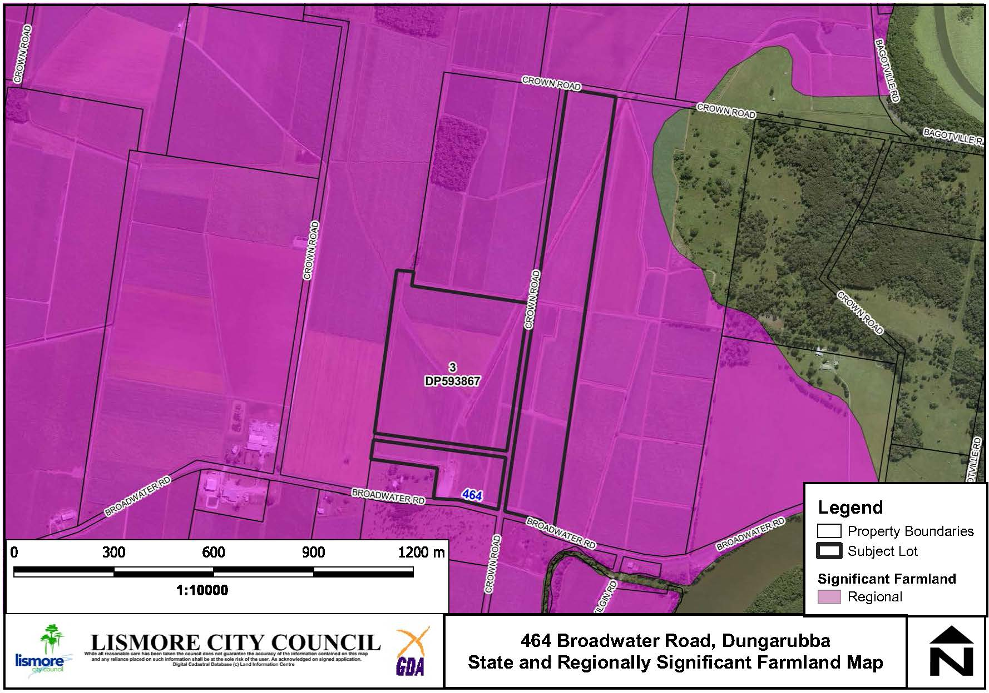

**Figure 9: Regionally Significant Farmland.**

#### **Q9. Has the planning proposal adequately addressed any social and economic effects?**

**Aboriginal and European Cultural Heritage**

An Aboriginal Heritage Information Management Systems (AHIMS) search was undertaken and no Aboriginal sites or places were identified within 50 metres of the subject land. The land is also not listed as a heritage item in Schedule 5 of the Lismore LEP 2012.

**Social and Economic Impact**

A LUCRA has been prepared and demonstrated that the impact of the proposed development on surrounding dwellings will be low and can be adequately managed. The proposal does not trigger the requirement for a Social Impact Assessment (SIA) under section 5.3 of the LCC SIA guidelines.

The Planning Proposal will permit a manufacturing industry on the site that will provide economic benefits associated with the ongoing employment of six (6) staff. The proposal does not displace any employment lands and will not negatively impact upon other employment centres.

## Section D – State and Commonwealth interests

#### **Q10. Is there adequate public infrastructure for the planning proposal?**

**Road Network**

The proposed activity will require deliveries of premixed concrete (ie 3 trucks) per daily pour. A visual condition assessment was undertaken during the site inspection with the existing road network assessed as being suitable to cater for this low volume of heavy vehicles. Existing Broadwater Road is a local collector road and is of good condition with 7m seal width. This road has been subject to upgrades via Building Better Regions road funding over several years. Wyrallah Road is a regional road and is also in a good to fair condition to service the facility in its function as a transport corridor.

The nature of the proposal will not require any additional services in relation to water, sewer, power or telephone/NBN.

#### **Q11. What are the views of State and Commonwealth public authorities consulted in accordance with the Gateway determination?**

It is recommended that Roads and Maritime Services, Department of Primary Industries and the Natural Resource Access Regulator (Land and Water Division of the Department of Planning, Industry & Environment) are consulted following the Gateway Determination.

# Part 4 - Mapping

The Additional Permitted Uses LEP Map will be amended as shown below to identify part of 464 Broadwater Road, Dungarubba (Part Lot 3 DP 593867) as Item 7.

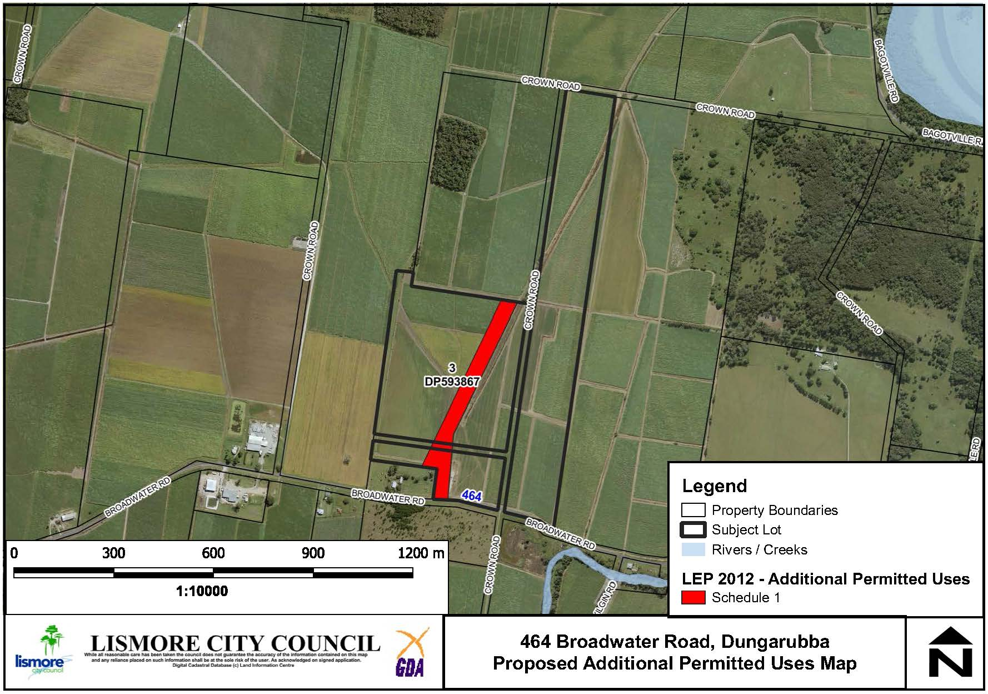

**Figure 10: Proposed Additional permitted Use Map**

In addition to the above map, the LEP written instrument Schedule 1 is proposed to be amended as follows;

**7 Use of certain land at 464 Broadwater Road, Dungarubba**

1. This clause applies to the part of the land at 464 Broadwater Road, Dungarubba, being approximately 3.3 hectares at Lot 3 DP 593867 identified as “Item 7” on the Additional Permitted Use Map.
2. Development for the purpose of a General Industry (limited to the manufacturing of concrete erosion mats) is permitted with development consent on the land to which this clause applies

# Part 5 - Community Consultation

Council will commence community consultation post Gateway determination. For the purposes of public notification, Council considers that a twenty eight (28) day public exhibition period is appropriate.

Notification of the exhibited planning proposal will include:

* A newspaper advertisement (Local Matters) that circulates in the area affected by the planning proposal;
* On the website of Lismore City Council and the Department of Planning, Industry and Environment; and
* A letter to adjoining landowners
* Referral to the Ngulingah Local Aboriginal Land Council

The written notice will:

* Provide a brief description of the objectives or intended outcomes of the planning proposal;
* Indicate the land that is the subject of the planning proposal;
* State where and when the planning proposal can be inspected; and
* Provide detail that will enable members of the community to make a submission.

Exhibition Material:

* The planning proposal, in the form approved for community consultation by the Director General of the Department of Planning, Industry and Environment.
* The Gateway determination.
* Any studies required as part of the planning proposal.

The Gateway determination will confirm the public consultation requirements.

# Part 6 - Project Timeline

It is anticipated that the planning proposal will be completed within the indicative timeline shown below:

* Report to Council – **November 2019**
* Gateway determination issued – **December 2019**
* Agency and public consultation – **January / February 2020**
* Consideration of submissions – **March 2020**
* Council consideration of the proposal post exhibition – **April 2020**
* Anticipated date of submission to the Department for notification of the making of the LEP – **May 2019**
* Anticipated date for plan making - **June 2019**

# 

# Conclusion

The Planning Proposal to amend Schedule 1 of the Lismore LEP to allow an industrial activity (erosion mat manufacturing) at 464 Broadwater Road, Dungarubba is considered to be consistent with the objectives of the RU1 zone and no land use conflicts with surrounding land uses have been identified. The unique site requirements of the proposal prohibit the activity being undertaken on existing Industrial land within the Lismore LGA, or on land identified for Industrial use within the Growth management Strategy.

The Planning Proposal is considered to be consistent with the North Coast Regional Plan and the relevant SEPPs and Section 9.1 Ministerial Directions**.**

## APPENDIX 1 Compliance with applicable State Environmental Planning Policies

|  |  |  |
| --- | --- | --- |
| **State Environmental Planning Policy** | **Requirements** | **Compliance** |
| **SEPP 44 – Koala Habitat Protection** | **3**   **Aims, objectives etc**  To encourage the proper conservation and management of areas of natural vegetation that provide habitat to koalas…   (a)  by requiring the preparation of plans of management before development consent can be granted in relation to areas of core koala habitat, and  (b)  by encouraging the identification of areas of core koala habitat, and  (c)  by encouraging the inclusion of areas of core koala habitat in environment protection zones.  **16**   **Preparation of local environmental studies**  The Director General may require that potential or core koala habitat not proposed for environmental protection zoning is the subject of an environmental study. | The land subject to this Planning Proposal has been cleared of vegetation as a result previous farming activities. LCC’s mapping does not show any primary or secondary koala habitat on the site. No vegetation is proposed to be removed as a result of the proposal. |
| **SEPP 55 – Remediation of Land** | **6**   **Contamination and remediation to be considered in zoning or rezoning proposal**  Council is required to consider whether the land is contaminated when rezoning for residential development. | The proposal will not involve any soil disturbance. Therefore it does not trigger the requirement for a preliminary contaminated land assessment. |
| **SEPP (Primary Production and Rural Development) 2019** | Not applicable | Not applicable |
| **SEPP (Coastal Management) 2018** | The aim of this Policy is to promote an integrated and co-ordinated approach to land use planning in the coastal zone in a manner consistent with the objects of the [Coastal Management Act 2016](https://www.legislation.nsw.gov.au/#/view/act/2016/20), including the management objectives for each coastal management area, by:  (a)  managing development in the coastal zone and protecting the environmental assets of the coast, and  (b)  establishing a framework for land use planning to guide decision-making in the coastal zone, and  (c)  mapping the 4 coastal management areas that comprise the NSW coastal zone for the purpose of the definitions in the [Coastal Management Act 2016](https://www.legislation.nsw.gov.au/#/view/act/2016/20). | The site is mapped as containing areas of both (a) Coastal use Area and (b) Coastal Environment Area.  The SEPP requires a range of matters relating to the protection of coastal areas to be considered when seeking a development consent.  Therefore the provisions within the SEPP are not applicable to this Planning Proposal. However, it is considered that all necessary matters can be satisfactorily addressed with any subsequent DA. |
| **SEPP (Infrastructure) 2007** | The aim of this Policy is to facilitate the effective delivery of infrastructure across the State by:  (a)  improving regulatory certainty and efficiency through a consistent planning regime for infrastructure and the provision of services, and  (b)  providing greater flexibility in the location of infrastructure and service facilities, and  (c)  allowing for the efficient development, redevelopment or disposal of surplus government owned land, and  (d)  identifying the environmental assessment category into which different types of infrastructure and services development fall (including identifying certain development of minimal environmental impact as exempt development), and  (e)  identifying matters to be considered in the assessment of development adjacent to particular types of infrastructure development, and  (f)  providing for consultation with relevant public authorities about certain development during the assessment process or prior to development commencing, and  (g)  providing opportunities for infrastructure to demonstrate good design outcomes. | Clause 104 – Traffic generating development and Schedule 3 applies. The proposal will be referred to RMS post-Gateway determination. |

## APPENDIX 2 – Compliance with Section 9.1 Ministerial Directions

| **Ministerial Directions** | **Requirements** | **Compliance** |
| --- | --- | --- |
| **1.   Employment and Resources** | | |
| 1.1 Business and Industrial Zones | Not applicable | **Not applicable** |
| 1.2 Rural Zones | A Planning Proposal must not rezone land from a rural zone to a residential zone unless it is justified under clause 5 of the direction. Such justification includes the identification of the land in a strategy. | **Not applicable**  The Planning Proposal does not propose the rezoning of land from a rural to residential zone. |
| 1.3 Mining Petroleum Production and Extractive Industries | This direction applies when the Planning Proposal:  Has the effect of prohibiting mining of coal or other minerals, production of petroleum, or winning or obtaining extractive materials;  Restricting the potential  of State or regionally significant mineral resources | **Not applicable** |
| 1.4 Oyster Aquaculture | Not applicable | **Not applicable.** |
| 1.5 Rural Lands | This direction applies when:   * The planning proposal effects land within an existing or proposed rural or environmental protection zone; * When changes are proposed to minimum lot size in a rural or environmental protection zone.   The Planning Proposal must:   * Be consistent with any applicable strategic plan; * Consider the significance of agriculture; * Identify and protect environmental values; * Consider the natural and physical constraints of the land; | **Consistent**  This Planning Proposal effects land within a rural zone that is mapped as Regionally Significant Farmland. The proposal seeks to allow an industrial activity, the manufacturing of concrete erosion mats, by adapting and widening a redundant internal driveway. The remainder of the land will be retained for agricultural use. It is considered that the Planning Proposal;   * is consistent with the North Coast Regional Plan, in particular directions 6 & 11 which have been discussed in Question 3 and with Lismore Council’s CSP and GMS which are discussed at Question 4, * will not reduce the agricultural viability of the land as the majority of the site will be retained for ongoing agriculture use, being cattle grazing and sugar cane cropping, * will not have an adverse impact on environmental values,   has addressed all relevant site constraints at Question 8. |
| **2.   Environment and Heritage** | | |
| 2.1 Environment Protection Zones | The Planning Proposal must include provisions that facilitate protection of environmentally sensitive areas.  Must not reduce protection standards for environmental protection zones. | **Not applicable** |
| 2.2 Coastal Protection | **3 When this direction applies**  This direction applies to land that is within the coastal zone under the *Coastal Management* *Act 2016*.  4 A planning proposal must include provisions that give effect to and are consistent with:  (a) The objects of the Coastal Management Act 2016 and the objectives of the relevant coastal management area;  (b) The NSW Coastal Management Manual and associated Toolkit;  (c) NSW Coastal Design Guidelines 2003;  (d) Any relevant Coastal Management  Program or Coastal Zone Management Plan. | **Not applicable** |
| 2.3 Heritage Conservation | Planning proposal must incorporate provisions for conservation of European and Aboriginal heritage items or places. | **Consistent**  The site is not identified as an area of heritage significance within the Lismore LEP and an AHIMS search did not identify any Aboriginal sites or places within 50m of the subject land. |
| 2.4 Recreation Vehicle Areas | Not applicable | **Not applicable** |
| 2.5 Application of E2 and E3 Zones and Environmental Overlays in Far North Coast LEPs | A planning proposal that introduces or alters an E2 or E3 zone or an overlay must apply zones and clauses consistent with the Northern Councils E Zone Review Final Recommendations | **Not applicable** |
| **3.   Housing, Infrastructure and Urban Development** | | |
| 3.1 Residential Zones | Where applicable a Planning Proposal must include provisions that encourage the provision of housing that will:   1. Broaden the choice of housing types and locations. 2. Make efficient use of existing infrastructure and services. 3. Reduce consumption of land on the urban fringe. 4. Housing of good design.   In addition, a planning proposal must:   * Contain a requirement that residential development is not permitted until land is adequately serviced. * Not contain provisions that will reduce permissible residential density of land. | **Not applicable** |
| 3.2 Caravan Parks and Manufactured Home Estates | 1. Retain provisions that permit development of caravan parks. 2. Retain zonings of existing caravan parks. 3. Take into account principles for siting manufactured home estates. | **Not applicable** |
| 3.3 Home Occupations | The Planning Proposal must permit home occupations in dwelling houses without development consent. | **Not applicable** |
| 3.4 Integrating Land Use and Transport | The Planning Proposal must give effect to and be consistent with the aims, objectives and principles of:   1. *Improving Transport Choice* – *Guidelines for planning and development* (DUAP 2001)  * better integrate land use and transport planning and development, * provide transport choice and manage travel demand to improve the environment, accessibility and livability, * reduce growth in the number and length of private car journeys, * make walking, cycling and public transport use more attractive.  1. *The Right Place for Business and Services* – *Planning Policy* (DUAP 2001)   This policy aims to encourage a network of vibrant, accessible mixed use centres that are closely aligned with and accessible by public transport, walking and cycling. Objectives include:   * help reduce reliance on cars and moderate the demand for car travel * encourage multi-purpose trips * encourage people to travel on public transport, walk or cycle * provide people with equitable and efficient access * protect and maximise community investment in centres, and in transport infrastructure and facilities * foster growth, competition, innovation and investment confidence in centres, | **Not applicable** |
| 3.5 Development Near Licensed Aerodromes | Not applicable | **Not applicable.**  The site is not in the vicinity of a licensed aerodrome. |
| 3.6 Shooting Ranges | Not applicable | **Not applicable.**  The site is not located adjacent to an existing shooting range. |
| **4.   Hazard and Risk** | | |
| 4.1 Acid Sulfate Soils | This direction applies when a planning  authority prepares a planning proposal that will apply to land having a probability of containing acid sulfate soils. | The site is mapped as containing Class 3 acid sulfate soils. The s9.1 direction requires that the Planning Authority must not propose an intensification of land use on land containing acid sulfate soils unless an acid sulfate soils study assessing the appropriateness of the change in land use.  As the proposal will not require any soil disturbance, no technical reporting regarding acid sulfate soils is required. The relevant provision of the LEP will be addressed post-Gateway determination with any future development application. |
| 4.2 Mine Subsidence and Unstable Land | Applies to mine subsidence areas  Applies to areas identified as unstable | **Not applicable.** |
| 4.3 Flood Prone Land | 5) A planning proposal must not rezone land within the flood planning areas from Special Use, Special Purpose, Recreation, Rural or  Environmental Protection Zones to a  Residential, Business, Industrial, Special Use or Special Purpose Zone.  (6) A draft LEP shall not contain provisions that apply to the flood planning areas which:  (a) permit development in floodway areas,  (b) permit development that will result in  significant flood impacts to other properties,  (c) permit a significant increase in the  development of that land,  (d) are likely to result in a substantially  increased requirement for government  spending on flood mitigation measures,  infrastructure or services, or  (e) permit development to be carried out  without development consent except for the purposes of agriculture (not including dams, drainage canals, levees, buildings or structures in floodways or high hazard areas), roads or exempt development. | **Consistent.**  The Planning Proposal does not seek to rezone the subject land. The Planning Proposal is consistent with Clause (6) of the s.9.1 direction in that:   1. the site is not mapped within a floodway area 2. the Planning Proposal will not result in significant flood impact to other properties 3. The Planning Proposal seeks to use an existing driveway within the land. The development footprint is therefore considered to be minimal. Other proposed structures are limited to two shipping containers connected by a dome shaped roof for machinery weather protection. The additional traffic movement generated by the development are not considered to be significant. 4. The Planning Proposal will not require government spending on flood mitigation measures 5. The Planning Proposal will not permit any additional development to be carried out without consent. |
| 4.4 Planning for Bushfire Protection | A Planning Proposal in bush fire prone land:   1. Is to be referred to the Commissioner of the NSW Rural Fire Service following receipt of a gateway determination and prior to community consultation. 2. Have regard to Planning for Bush Fire Protection 2006. 3. Restrict inappropriate development from hazardous areas. 4. Ensure bush fire hazard reduction is not prohibited within the APZ. | **Not applicable.** |
| **5.   Regional Planning** | | |
| 5.1 Implementation of Regional Strategies | The Planning Proposal must be consistent with the Far North Coast Regional Strategy. | **Consistent.**  The Planning Proposal is consistent with the North Coast Regional Plan, as addressed in Part 3, Q3 of this report. |
| 5.2 Sydney Drinking Water Catchments | Not applicable | **Not applicable** |
| 5.3 Farmland of State and Regional Significance on the NSW Far North Coast | The Planning Proposal must not rezone land mapped as State or regionally significant farmland under the Northern Rivers Farmland Protection Project.  The Direction does not apply to areas contained within a ‘town and village growth boundary’ in the Far North Coast Regional Strategy. | **Consistent.**  The Planning Proposal does not seek to rezone any land. The site is mapped as regionally significant farmland and the majority of the site will be retained for farming purposes. |
| 5.4 Commercial and Retail Development along the Pacific Highway, North Coast | Not applicable. | **Not applicable.** |
| 5.8 Second Sydney Airport: Badgerys Creek | Not applicable. | **Not applicable.** |
| **6.   Local Plan Making** | | |
| 6.1 Approval and Referral Requirements | A Planning Proposal should not contain provisions requiring concurrence, consultation or referral of a Minister or public authority without approval from the relevant Minister or public authority; and the Director General of the Department of Planning. It must not identify development as designated development unless justified. | **Consistent.**  The Planning Proposal does not introduce new concurrence, consultation or referral requirements. Nor does it propose new forms of designated development. |
| 6.2 Reserving Land for Public Purposes | A Planning Proposal must not create, alter or reduce existing zonings or reservations of land for public purposes without approval of the relevant public authority and the Director General of the Department of Planning. | **Consistent.**  This planning proposal does not affect public land. |
| 6.3 Site Specific Provisions | A Planning Proposal to allow a particular land use (residential development) must rezone the site to an existing zone already applying to the LEP that allows the land use, without additional development standards to those already in use in that zone. | **Consistent.**  The Planning Proposal does not impose any development standards or requirements in addition to those already in use. |
| **7.   Metropolitan Planning – Not applicable** | | |